Process Document

This coding project is my personal examination on what forgiveness means and who deserves it according to the traditional Catholic ideals I grew up with. The message I hoped to relay is that no matter how selfless one is or how willing others are to become “innocent,” they are still guilty of small offenses. We are all human, and to critique another’s soul is to condemn your own.

This project was inspired by Francisco de Goya’s *The Witches’ Flight* as well as a video game his paintings went on to later provide inspiration for, *Blasphemous*. They share similarities in their designs and themes; both are inspired by Spanish Catholicism, (the creators of *Blasphemous* and Francisco de Goya himself were Spanish) both in its visuals and values. The visuals of *Blasphemous* feature imagery closely related to Catholicism like convents, rosaries, kneeling, angels with many heads, etc. as well as a running theme of endless penance to repent for one’s own existence. *The Witches’ Flight* utilizes vague imagery to hint at deeper meanings that are revealed upon researching the context of the painting’s creation; the witches’ crowns are emblematic of the clothes those condemned by the Spanish Inquisition were forced to wear, whether they were innocent or not.

I utilized these themes in my project in the mechanics and language used. Every person that approaches you to be forgiven is identified solely by their wrongdoings. Their only identifying attributes are their sins, which was a message I heard a lot growing up; we were all guilty of something, and any mistake was labeled a sin, regardless of what its severity or intention. I communicated that in the limited information provided for each infidel. The context of their actions is not provided, leaving it to the player to decide how to proceed. The language is also important, as it uses terminology commonly found in religious environments, both in the final product and the code itself. The “sinners” are referred to as infidels in the code, those who do not believe in a religion. The end screen always displays the message of, “Continue Penance?” penance being a long-running motif of Catholicism, particularly in that it is the only way to get to heaven.

# UI Sketches

1. Overall UI. (blue are buttons/functions, green is text, red is notes)
2. Death/losing screen.
3. Canonization/winning screen.
4. Painting inspiration.
5. Color scheme.
6. Word bubble.
7. Text formatting reference document.
8. Analysis of *The Witches’ Flight*.

# 

Francisco De Goya, *The Witches’ Flight*, 1789.

Color scheme used.

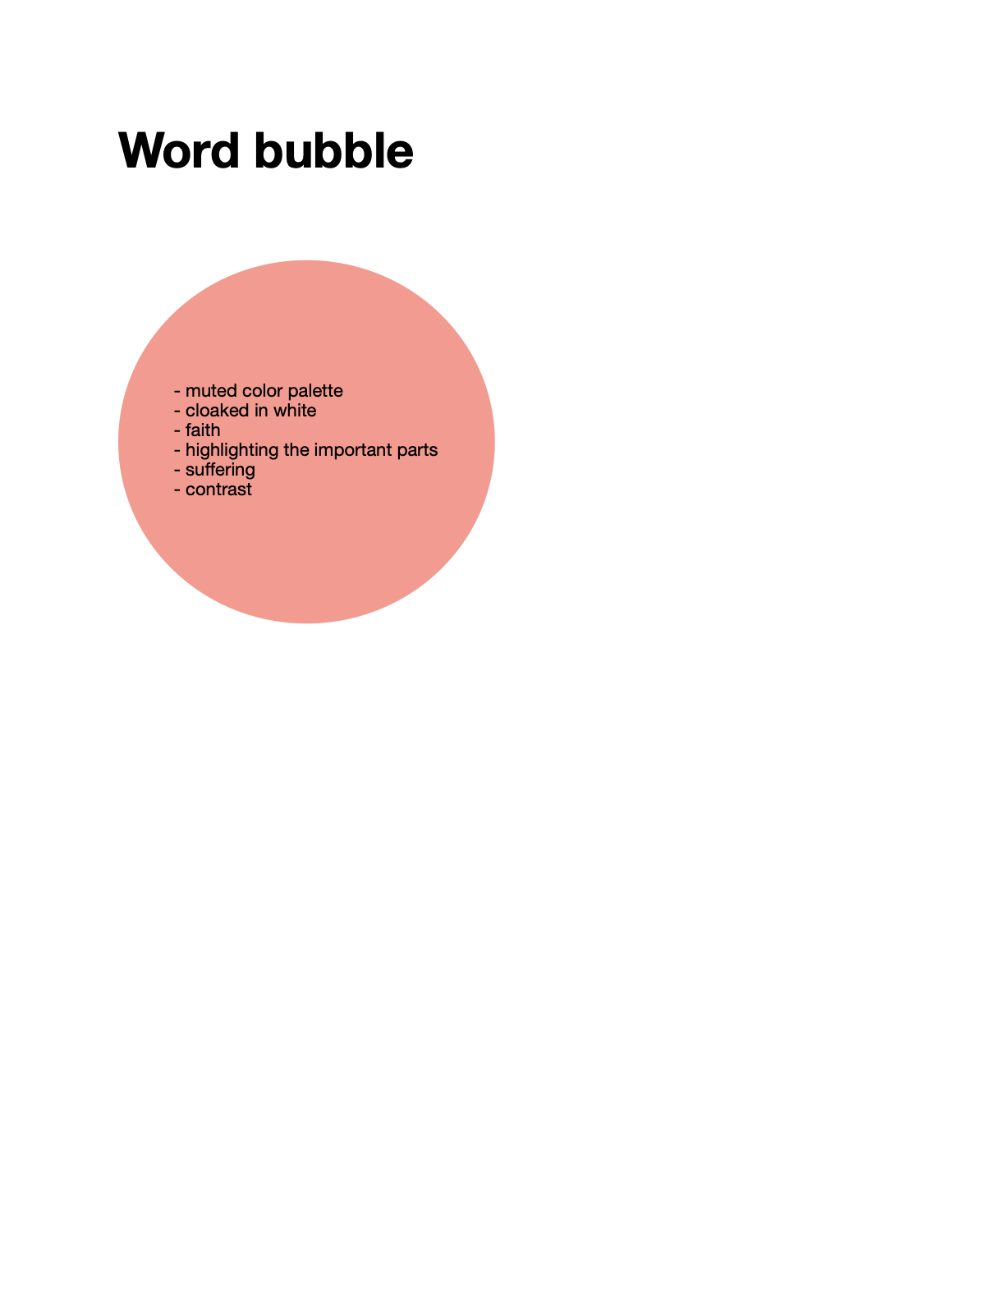

Word bubble parts used:

* Muted color palette, as seen above.
* Player’s figure is cloaked in white.
* Important components like the “game title” and decision dot are highlighted in white.
* Any option the player makes leads to an unhappy ending.

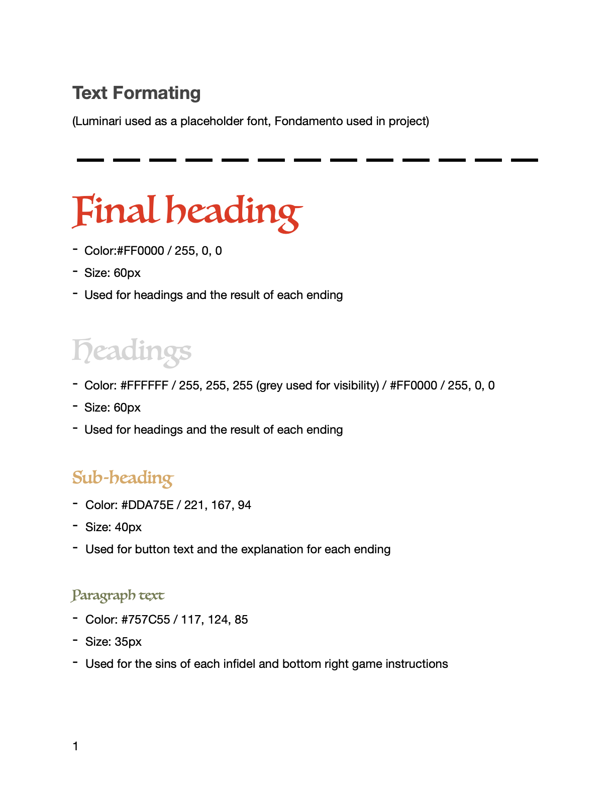

Both this image and the one above was used as references for the game’s text formatting.

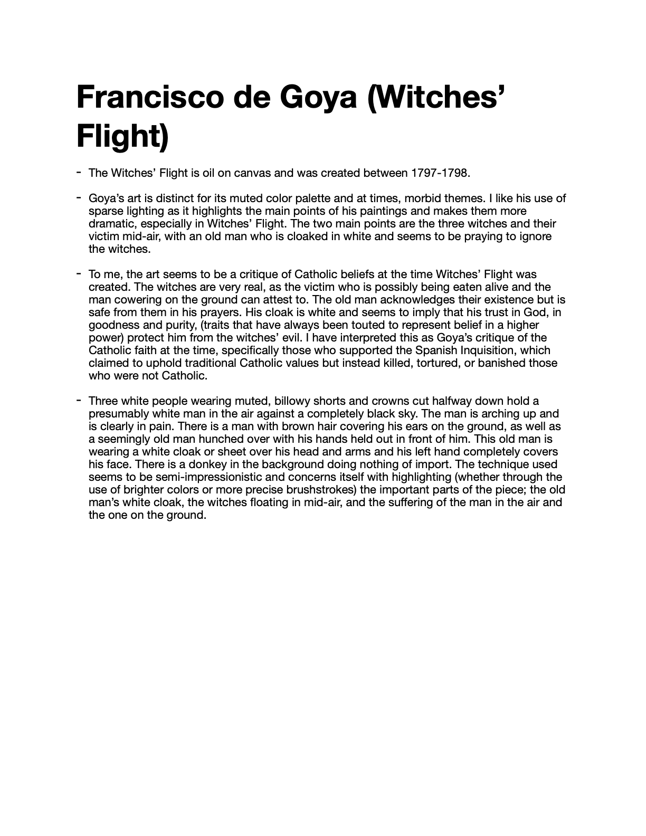

The analysis of The Witches’ Flight done at the beginning of the project.